

Motor calculation test plan

Propulsion system simulation

Fangzhou chen Jiacong li Marco Hoogesteger Martijn Crombeen

*Organisation: Solar Boat Sealander*

*Client: Mr. R. Eijlers*

*Tutor: Mr. W. Haak*

*Date: 21-21-2020*

2020

Table of content

1. Aim & Hypothesis 2

1.1. Aim 2

1.2. Hypothesis 2

2. Variables 2

2.1. Inputs 2

2.2. Outputs 2

3. Tools 3

4. Method 4

4.1 Realistic calculation 4

4.2 Theoretical calculation 5

5.Steps 6

6.Expect result 6

# Aim & Hypothesis

## Aim

Establish a mathematical model for the relationship between the output and input of the motor

## Hypothesis

The output power, torque, rotation speed can be calculated by the input velocity and digital twin can be made.

# Variables

These are the constants and variables that will be used during the test.

|  |  |
| --- | --- |
| Constants simulation | Keep constant at... |
| Ambient temperature | Standard indoor temperature with lower and upper limits (20 ℃ ± 5℃). |
| Battery level computer | Constant power source. |
| All input variables | Real positive numbers & ISO-notation. |

## Inputs

The limits stated are the limits of the real world. If values out of this range are entered, the outputs will be unreliable. Due to the impact of the epidemic, we will use Plan B to simulate the system based on the data sheet.

|  |  |
| --- | --- |
| General input | Value |
| Motor efficiency | 0.84-0.88 |
| Current torque relation coefficient: | 0.18 |

|  |  |
| --- | --- |
| Inputs for realistic calculation | Value |
| Boat velocity | [0,17] [Km/h] |

|  |  |
| --- | --- |
| Inputs for theoretical calculation | Value |
| Feedback torque from gear | - |
| Feedback rotation speed from gear | - |
| Gearing power loss | - |

## Outputs

These are the outputs that will be monitored and will be used to see variations or changes in the system. Due to the impact of the epidemic, we will use Plan B to simulate the system based on the data sheet.

|  |  |
| --- | --- |
| Outputs from realistic calculation | Value |
| Motor power output | [0,8800] [w] |
| Motor torque output | [0,40] [Nm] |
| Motor rotation speed ouput | [0,2400] [rpm] |
| Motor power input | [0,8800] [w] |

|  |  |
| --- | --- |
| Output from theoretical calculation | Value |
| Motor input voltage | - |
| Motor input current | - |
| Motor input power |  |

# Tools

|  |  |
| --- | --- |
| Testing tools | Demand |
| Computer | Windows 10 compatible |
| Excel | Newest version |
| Keyboard | No limit |
| Mouse | No limit |
| Calculator | Basic calculator |
| Pen & Paper | Basic pen & paper |
| Datasheet | Solar boat relevant data |

# Method

## 4.1 Realistic calculation

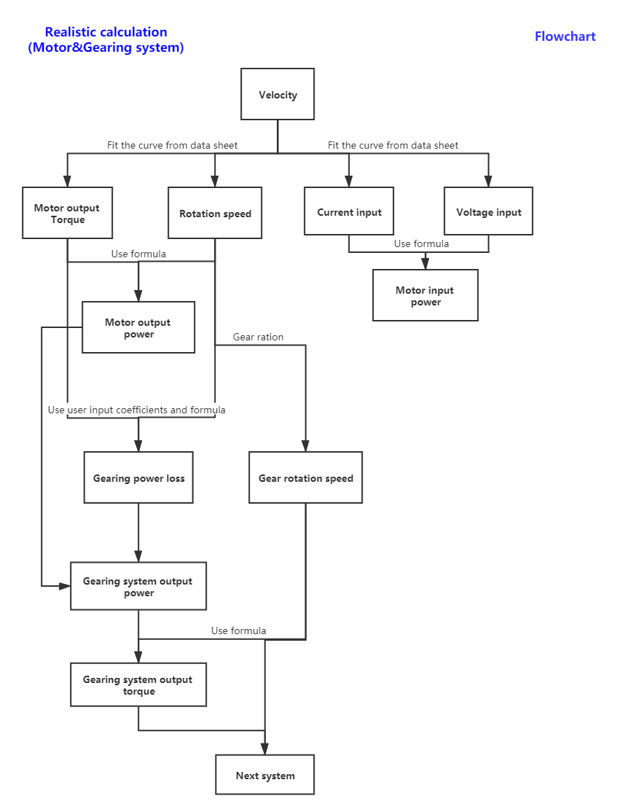

The motor part is inside the red frame.

## 4.2 Theoretical calculation

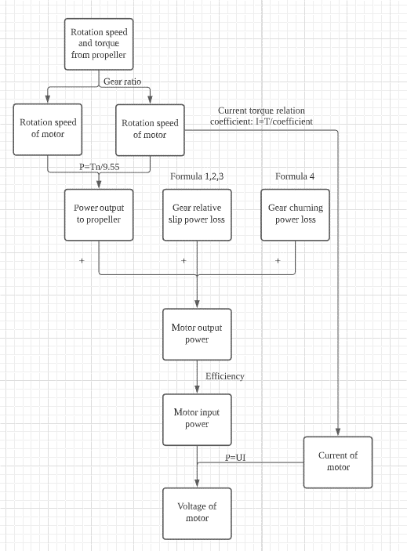

The motor part is inside the red frame.

4.3 Compare

When inputting the speed of the ship, compare the motor input and output voltage and current calculated by fitting the curve with the theoretically calculated motor input and output voltage and current. If the error is less than 30%, the digital twin is considered to be successfully established and the fitted curve is used in subsequent calculations.

# 5.Steps

* Enter target ship velocity in realistic calculation part.
* Obtain the motor output speed, torque, input voltage and current.
* Record these data and enter the theoretical calculation part.
* In the theoretical calculation section, enter the speed and torque fed back to the motor by the gear system at the corresponding ship speed.
* The approximate efficiency of the motor is automatically inferred from the realistic calculated input voltage.
* Get the input voltage and current of the motor.
* Verify the above calculations’ results by paper and pen.
* Determine whether the experiment is successful or not by comparing the results of the data table, theoretical calculation, and theoretical calculation.

# 6.Expect result

After the user collects data and enters it into the calculation chain, user enters the motor's input voltage, the motor's output power, torque and speed can be calculated.